|  |  |  |
| --- | --- | --- |
|  |  | **School Newsletter 20th November 2023 2023** |
| **Ltyentye Apurte Catholic School**  Church Street, Santa Teresa, PMB 221, Via Alice Springs, NT, 0872.  Telephone: (08) 8956 0937 email: robert.dreise@nt.catholic.edu.au |

Dear Families,

**All Souls Mass**

Father Ollie held a lovely All Souls Day Mass at the cemetery. Following Mass, Father blessed the graves with Holy Water and students prepared flowers and placed them on the graves. It was a special day for the school and the parish.

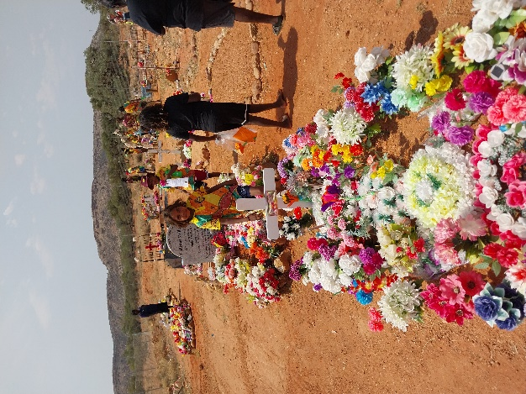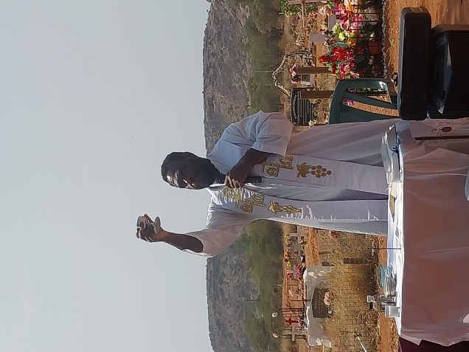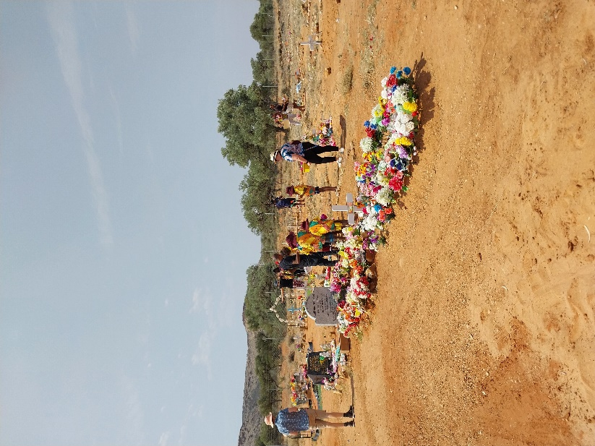

**Other News**

|  |  |
| --- | --- |
|  | Ltyentye Apurte Catholic School will be closed to students this Thursday out of respect for the family of the late Kwementyaye Gorey. His funeral will be held at the Santa Teresa Catholic Church, Thursday 23rd November at 11:00am. You are invited to wear the colours of his favourite team, the West Coast Eagles (blue and yellow) or black and white. |
|  | We welcome Helen Currie who will be our relieving teacher for the next 3 weeks. Helen is an experienced teacher who will teach various classes. |
|  | This Monday, Tuesday and Wednesday, Cecily Palmer and CR will join Dr. Susan to represent our school at a conference in Wollongong outside of Sydney. They will be sharing information about our school as well as Arrernte culture. I am sure they will return with fond memories. |
|  | **A reminder that our school is closed before 7:45am. Breakfast will be served at 8:00am**. A big thank you to Tony our Chef and Brother Francis for preparing and serving breakfast. Thanks also to Larissa for helping to prepare morning tea and lunch for the students. |
|  | We are excitied to announce that one of our teaching blocks (the new building) will be receiving a bright new look. Our Arrernte staff including Jane, Tina, Sheree, Renee and Marcus, along with others will be painting the front of the building. The mural will display our school values as well as feature local Arrernte artwork. We look forward to the finished product. |
| [This Photo](https://www.wisc-online.com/asset-repository/viewasset?id=1276) by Unknown Author is licensed under [CC BY-NC](https://creativecommons.org/licenses/by-nc/3.0/) | **Monday November** **20th**  Arrernte Language and Culture Staff to Wollongong.  **Thursday November 23rd**  Ltyentye Apurte Catholic School Closed for Sorry Business  **Monday November** **27th**  School Disco 11:30 – 12:30 J1, J2 & J3. 1:45 – 3:00 J4, M1, S1 SL**.**  **Tuesday November 28th**  Blue Earth Games  **Thursday November 30th**  J4 Excursion  **Sunday December 3rd**  1st Sunday of Advent |

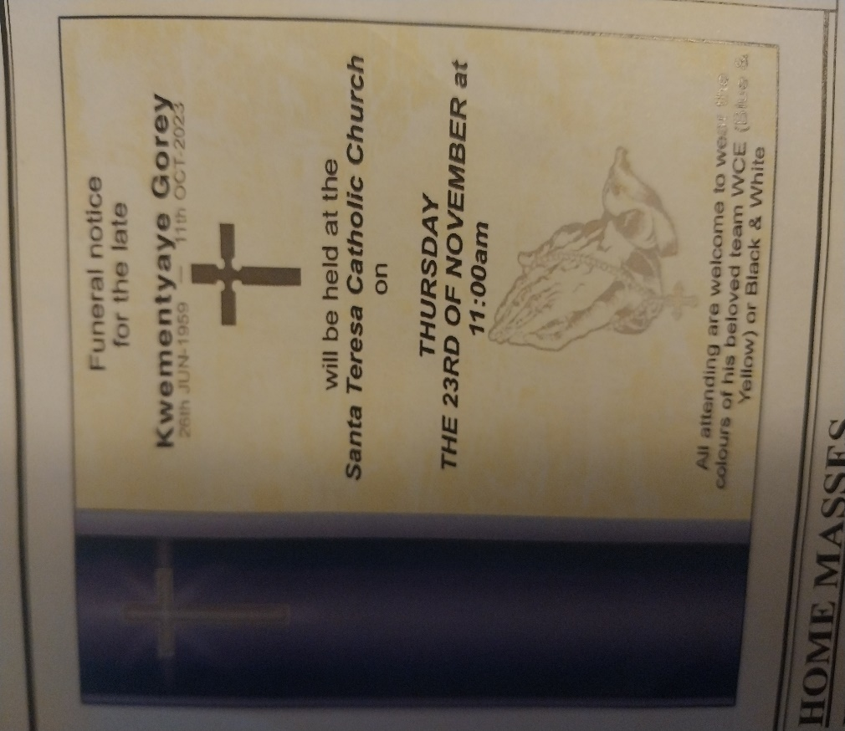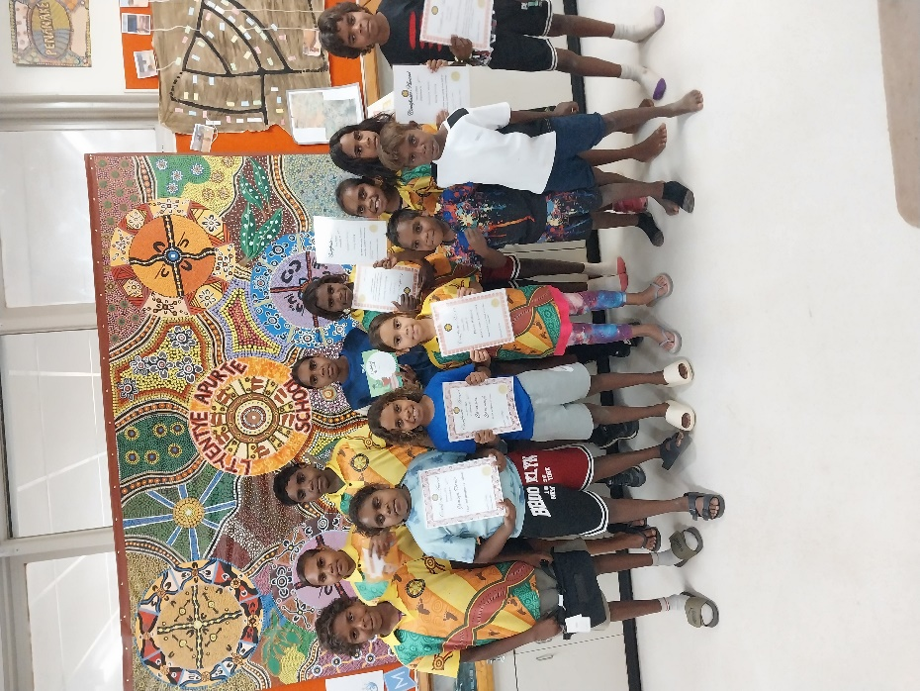

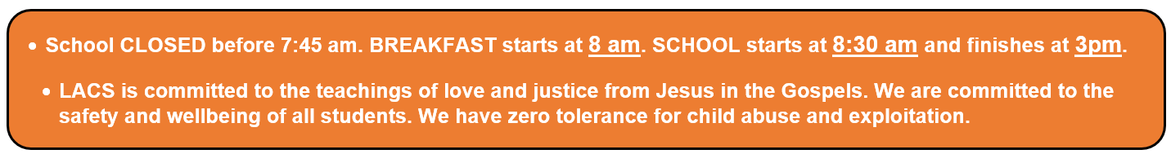

Mr. D

Principal